Sinusitis

**Sinusitis is an inflammation or swelling of the tissue lining the sinuses. Healthy sinuses are filled with air. But when they become blocked and filled with fluid, germs can grow and cause an infection.**

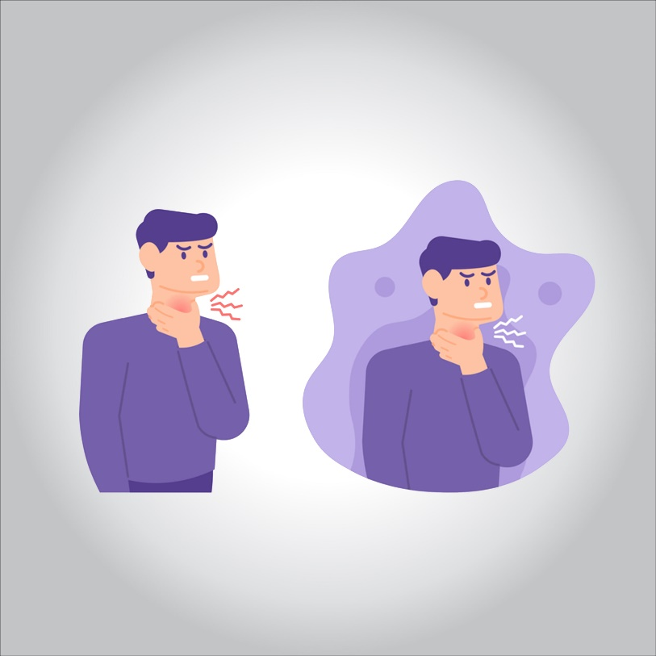

**Conditions that can cause sinus blockage include:**

* **The common cold**
* **Allergic rhinitis, which is swelling of the lining of the nose**
* **Small growths in the lining of the nose called nasal polyps**
* **A deviated septum, which is a shift in the nasal cavity**

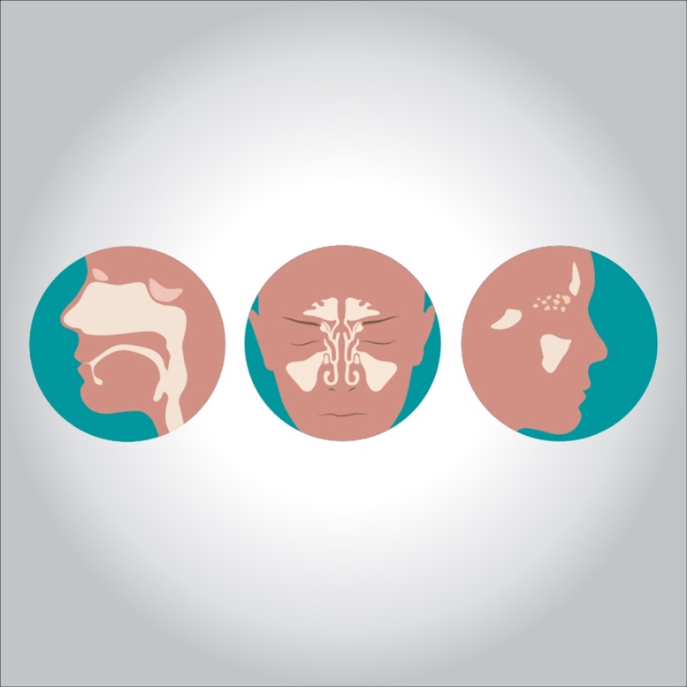

**Types**

**You may hear your doctor use these terms:**

* **Acute sinusitis usually starts with cold like symptoms such as a runny, stuffy nose and facial pain. It may start suddenly and last 2-4 weeks.**
* **Subacute sinus inflammation usually lasts 4 to 12 weeks.**
* **Chronic inflammation symptoms last 12 weeks or longer.**
* **Recurrent sinusitis happens several times a year.**

**Who Gets It?**

**Lots of people. It’s more likely if you have:**

* **Swelling inside the nose like from a common cold**
* **Blocked drainage ducts**
* **Structural differences that narrow those ducts**
* **Nasal polyps**
* **Immune system deficiencies or medications that suppress the immune system**

**For children, things that can cause sinusitis include:**

* **Allergies**
* **Illnesses from other kids at day care or school**
* **Pacifiers**
* **Bottle drinking while lying on the back**
* **Smoke in the environment**

**The main things that make sinusitis more likely for adults are infections and smoking.**

**Acute Sinusitis Symptoms**

**The main signs include:**

* **Facial pain or pressure**
* **“Stuffed-up” nose**
* **Runny nose**
* **Loss of smell**
* **Cough or congestion**

**You may also have:**

* **Fever**
* **Bad breath**
* **Fatigue**
* **Dental pain**

**It may be acute sinusitis if you have two or more symptoms or thick, green, or yellow nasal discharge.**

**Chronic Sinusitis Symptoms**

**You may have these symptoms for 12 weeks or more:**

* **A feeling of congestion or fullness in your face**
* **Nasal obstruction or nasal blockage**
* **Pus in the nasal cavity**
* **Fever**
* **Runny nose or discolored postnasal drainage**
* **You may also have headaches, bad breath, and tooth pain. You may feel tired a lot.**

**Lots of things can cause symptoms like these. You’ll need to see your doctor to find out if you have sinusitis.**

**Can I Prevent Sinusitis?**

**There is no sure-fire way to prevent sinusitis. But there are some things that might help.**

* **Don’t smoke, and avoid other people’s smoke.**
* **Wash your hands often, especially during cold and flu season, and try not to touch your face.**
* **Stay away from things you know you’re allergic to.**

**Treatment**

**Treatments for chronic sinusitis include:**

* **Nasal corticosteroids. These nasal sprays help prevent and treat inflammation. Examples include fluticasone, triamcinolone, budesonide, mometasone and beclomethasone. If the sprays aren’t effective enough, your doctor might recommend rinsing with a solution of saline mixed with drops of budesonide or using a nasal mist of the solution.**
* **Saline nasal irrigation, with nasal sprays or solutions, reduces drainage and rinses away irritants and allergies.**
* **Oral or injected corticosteroids. These medications are used to relieve inflammation from severe sinusitis, especially if you also have nasal polyps. Oral corticosteroids can cause serious side effects when used long term, so they’re used only to treat severe symptoms.**
* **Aspirin desensitization treatment, if you have reactions to aspirin that cause sinusitis. Under medical supervision, you’re gradually given larger doses of aspirin to increase your tolerance.**

**Antibiotics**

**Antibiotics are sometimes necessary for sinusitis if you have a bacterial infection. If your doctor can’t rule out an underlying infection, he or she might recommend an antibiotic, sometimes with other medications.**

**Immunotherapy**

**If allergies are contributing to your sinusitis, allergy shots (immunotherapy) that help reduce the body’s reaction to specific allergens might improve the condition.**

**Surgery**

**In cases resistant to treatment or medication, endoscopic sinus surgery might be an option. For this procedure, the doctor uses a thin, flexible tube with an attached light (endoscope) to explore your sinus passages.**

**Depending on the source of obstruction, the doctor might use various instruments to remove tissue or shave away a polyp that’s causing a nasal blockage. Enlarging a narrow sinus opening also may be an option to promote drainage.**